**E- MAIL APPLICATION**

**Errors Faced while building the project**

* **Introduction of document**
  1. This document gives a detailed description pf all the errors faced while building E-Mail Application using MEAN Stack application. E-Mail Application, as the name suggests a small project in which User can compose, archive and delete the emails.
* **Errors**
  + - 1. Error Message: TypeError: LoginModel.findOne is not a function at <file:///A:/Github%20artifacts/MailApplication/MailApplication/src/app/backend/routes/emailroutes.js:22:16>
         1. File Name and path: src/app/backend/routes/emailroutes.js
         2. Line Number: 22
         3. How did the error came up: From the User Interface, when we navigate to the Login page of the application, after entering the credentials we click on “Login”, it display the error
         4. Root Cause Analysis: findONe is not a typescript function, it is mongoose function, so the instance of the data model needs to be created as a collection using model function to export object as a mongoose object.

FileName : login.js

Line Number: 21

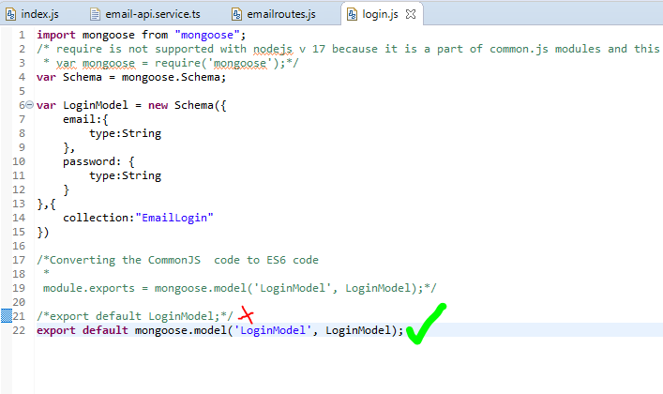

Description: As per above screenshot “export default LoginModel” is exporting just the object of type Schema to emailroutes.js which is considering findOne as a TypeScript function and throwing the above error

* + - * 1. Solution: Instead exporting just the object of type Schema(LoginModel), use “export default mongoose.model('LoginModel', LoginModel);”